Remove duplicates from sorted DLL
Problem Statement: Given the head of a doubly linked list with its values sorted in non-decreasing order. Remove all duplicate occurrences of any value in the list so that only distinct values are present in the list.

Algorithm
Since the list is sorted in non-decreasing order, any duplicates will always be adjacent.Compare each node with the next node. If they have the same value, skip the duplicate node (and delete it).
- Start at the head of the list and traverse until the current node and the next node are not null.
- If the next node has the same value as the current node:
  - Move forward until you find a node with a different value.
  - Delete all the duplicate nodes in between.
  - Link the current node to the first different node found.
- If the next node has a different value, move to the next node.
- Continue this process until the end of the list and return the head of the modified list.
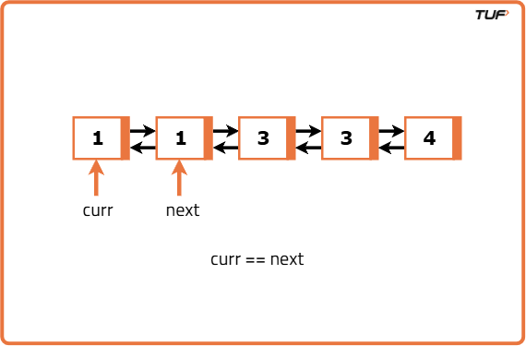
import java.util.*;

// Node class representing a node in a doubly linked list
class Node {
int data;
Node prev;
Node next;

// Constructor to initialize node with given value
Node(int value) {
data = value;
prev = null;
next = null;
}
}

// Solution class containing methods to manipulate the doubly linked list
class Solution {
Node head = null;

// Function to insert a node at the end of the list
public void insertAtEnd(int value) {
Node newNode = new Node(value);

// If list is empty, set new node as head
if (head == null) {
head = newNode;
return;
}

Node current = head;
while (current.next != null) {
current = current.next;
}

// Link the new node at the end
current.next = newNode;
newNode.prev = current;
}

// Function to remove duplicate values from a sorted doubly linked list
public Node removeDuplicates() {
// If the list is empty, return null
if (head == null) return null;

Node current = head;

// Traverse the list until the second last node
while (current != null && current.next != null) {
Node nextDistinct = current.next;

// Skip and unlink all nodes with the same value as current
while (nextDistinct != null && nextDistinct.data == current.data) {
nextDistinct = nextDistinct.next;
}
// Connect current node to the next distinct node
current.next = nextDistinct;
if (nextDistinct != null) {
nextDistinct.prev = current;
}
// Move to the next node
current = current.next;
}
return head;
}

// Function to print the list
public void printList() {
Node current = head;

while (current != null) {
System.out.print(current.data + " ");
current = current.next;
}
System.out.println();
}
}

